Procurement of FLiBe
Taesuk Oh

Very unlikely procurement of fluorine would cause a problem. Thus, focus on the following items:
- Procurement of Beryllium (Be)
- Procurement of Enriched Lithium (Li-6 Enrichment)
- Production capacity of FLiBe Facility
The ARC reactor postulates 90 at% Li-6 enriched FLiBe salt
[Beryllium Supply]
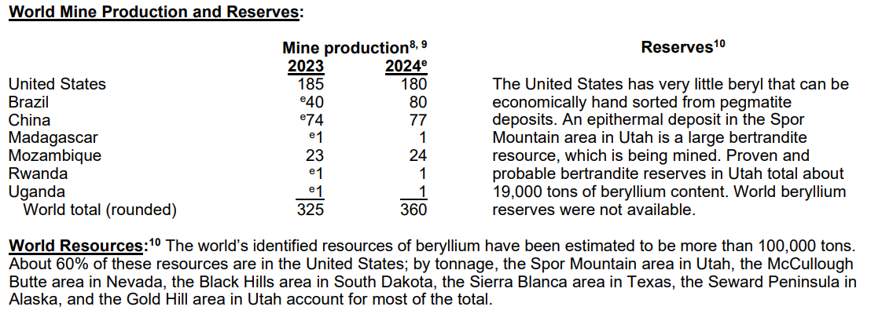
CAGR for Be market ~ 3.5%: Could estimate the growth in the annual Be procurement
: Depending on sources (reports) varies from 2.9% ~ 4.5%
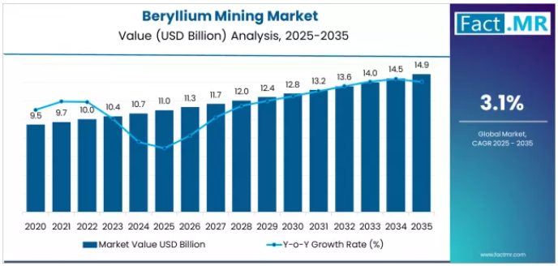

[Li-6 Supply Chain]
No readily available information. But, was able to retrieve some data from Kairos Power’s article.
Note that abundant Li availability, but it is the enrichment plant for Li-6.
Lithium Enrichment: Solving a U.S. Energy Security Problem (QUOTE from Kairos Power)
Kairos Power reactors require Flibe enriched to >99.99% in the lithium-7 isotope. Natural lithium contains ~92.5% lithium-7 and ~7.5% lithium-6. We must remove that ~7.5% before using the material in a reactor, where lithium-6 atoms would capture neutrons to make tritium – something we aim to minimize.
Kairos Power reactors are not the only ones that require enriched lithium. The U.S. light water reactor fleet uses enriched lithium hydroxide to control cooling water pH. However, there is currently no source of enriched lithium in the U.S. – it is primarily made in China and Russia. In parallel with our salt synthesis research, we began exploring how to close this domestic supply chain gap. We sought to develop a responsible, sustainable enrichment method that would alleviate the environmental concerns presented by the conventional column exchange (COLEX) process, which uses large amounts of mercury. We were determined to find a better way and to establish production in the U.S.
Working in the lab over several years and many iterations, the Salt Team developed an innovative, proprietary process to chemically isolate lithium-7 that meets the stringent specifications for Kairos Power reactors while honoring our mission to protect the environment. While our current focus is on producing material for the Kairos Power fleet, this new method could have broad applications within the U.S. nuclear industry.
We are now working to scale up our proprietary lithium enrichment capability, building a dedicated Salt Production Facility (SPF) in Albuquerque, N.M., which incorporates lessons learned from our lab-based testing and the Molten Salt Purification Plant.
The new facility will unify all stages of Flibe production: Using isotopic separation to remove lithium-6, turning the purified lithium-7 into lithium fluoride, and combining it with beryllium fluoride to make reactor-grade Flibe.
https://www.kairospower.com/updates/producing-a-1960s-molten-salt-coolant-for-21st-century-reactors

[FLiBe Facility Production Rate]
Again, from Kairos Power’s article:
Making FLiBe at Industrial Scale (QUOTE from Kairos Power)
Kairos Power’s Salt Team began designing the Molten Salt Purification Plant (MSPP) early on while Salt Lab operations were still ramping up. As we came to better understand our requirements, we overhauled the design, eliminating some purification steps before taking the concept from the page to construction.
We worked with Materion to build the pilot plant at their campus in Elmore, Ohio, and commissioned it in 2022. MSPP operators began producing Flibe for Kairos Power’s first Engineering Test Unit (ETU 1.0) – a reactor-scale, non-nuclear test built in part to exercise the supply chain and establish Flibe production.
Moving large volumes of salt through MSPP’s multi-stage process introduced many new challenges and learning opportunities. When charging lines repeatedly became plugged with salt, we reduced their thickness and weight to improve maintainability. When molten salt valves had issues with leakage, we replaced them with specially designed freeze valves to enhance performance and reliability.
Flibe production accelerated as we gained operational experience and made ongoing improvements to the plant. The first 2,000-kilogram batch took six months to produce. By the end, we were completing a new batch every 20 days. Within a year, and after considerable learning, we successfully produced 14 metric tons of Flibe in total and loaded 12 metric tons into ETU 1.0, making it the largest molten Flibe system ever built.
- Assuming a batch size of approximately 2 tons and a production cycle of one batch every 20 days, the facility can produce about 18 batches annually. This corresponds to a minimum annual FLiBe output of ~36 tons, or approximately ~3 tons per month.
The best we can postulate at the moment is that FLiBe facility can be scaled rather easily, providing enough amount of FLiBe to construct the ARC reactor.

